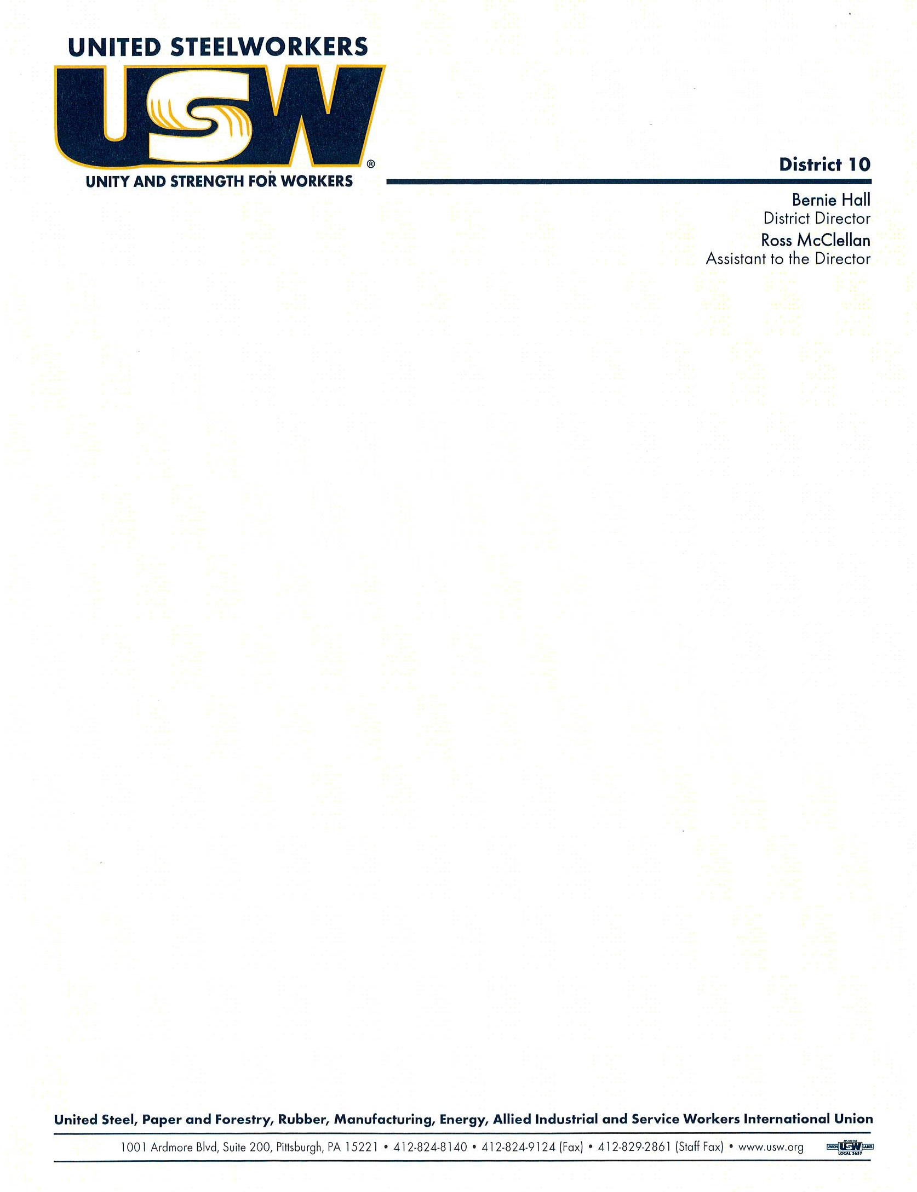

September 3, 2024

To: District 10 Presidents and Recording Secretaries

Dear Brothers and Sisters:

District 10 will be holding a one (1) day Union Approach to Safety Training class. Please see the locations and course description below:

|  |  |
| --- | --- |
| 1. **WHEATLAND, PENNSYLVANIA**   **FRIDAY, October 11, 2024**  Local Union Hall  107 Broadway Avenue  Wheatland, PA 16161 | 1. **PITTSBURGH, PENNSYLVANIA**   **FRIDAY, OCTOBER 18, 2024**  Local 2227 Union Hall  1301 Philip Murry Road  West Mifflin, PA 15122 |
| 1. **WILKES-BARRE, PENNSYLVANIA**   **FRIDAY, OCTOBER 25, 2024**  Local 15253 Union Hall (at a Church)  315-317 North Washington Street  Wilkes-Barre, PA 18705 | 1. **COATESVILLE**, **PENNSYLVANIA**   **FRIDAY, NOVEMBER 01, 2024**  Local 1165  750 Charles Street  Coatesville, PA 19320 |

Please note there is no Registration Fee for this training. Each class will begin at 8:30 am and end at 4:30 pm. Lunch will be provided. The class will teach participants how to approach Health and Safety from a Union perspective. This course educates local union members on how to create safer, healthier workplaces. Skills taught include how to involve members in the union’s health and safety activities, how to develop creative strategies to get tough problems addressed and how to build local union strength.

**Registration forms MUST be received at the District 10 office by Friday, October 7, 2024.** The class size is limited to forty (40) participants. Registrations will only be accepted after this date if the room is still available. Each Local Union will be responsible for any lost time, travel, and expenses. I encourage all Local Unions to participate in this important safety training course.

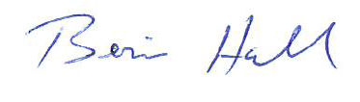Sincerely,

Bernie Hall, Director

USW District 10

BH/tlw

cc: Ashlee Fitch

Patricia (Trish) Creech

Steve Doherty

Staff Representatives and Administrative Assistants