United Steelworkers
District 10
Benefit Bike Run
March of Dimes for Babies
Saturday, July 26, 2025
USW District 10 Office
1001 Ardmore Blvd, Suite 200
Pittsburgh, PA 15221
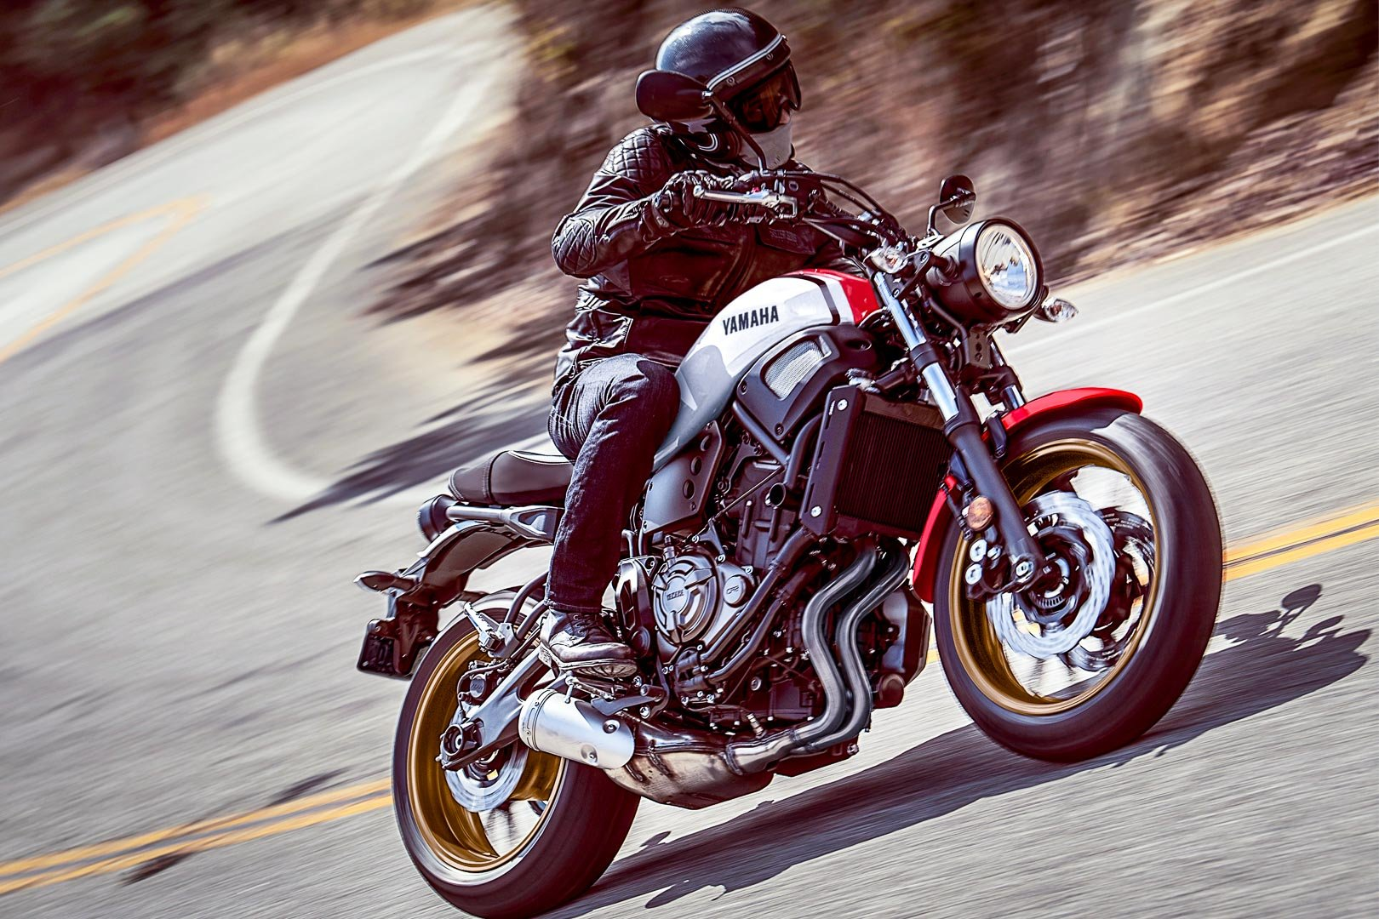

Note: Pre-registration is REQUIRED for all riders and passengers by June 9, 2025. There will be no registration on the day of the ride. All checks must be received in our office by Monday, June 9, 2025.

Ride begins at 10:00 am
Includes T-Shirt and Dinner

Rider: __________________________ Shirt Size:___________

Passenger: ______________________ Shirt Size:___________

Fee: $25 Per Person

Total Amount Enclosed: ___________ Check No.: __________

Make Checks Payable To: District 10 Recreation Fund

Mail Checks and Applications To: United Steelworkers District 10
C/O Rick Benson
1001 Ardmore Blvd, Suite 200
Pittsburgh, PA 15221

THERE WILL BE NO REFUNDS AFTER THIS DATE

