REGISTRATION FORM

Lobby Day Prep
Monday, June 9, 2025 (9:00 AM) ● Hilton Harrisburg, One North Second Street, Harrisburg

Lobby Day & Rally
Tuesday, June 10, 2025 (10:00 AM) ● Pennsylvania State Capitol, Downtown Harrisburg

Local Union # __________________________________________________________________
Local Union Contact Person’s Name _______________________________________________

Telephone # __________________ Email __________________________________________
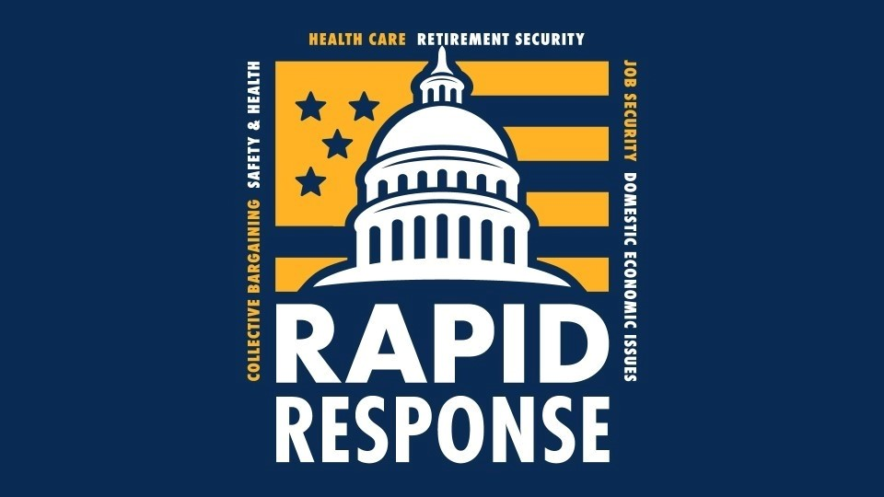

BUS NEEDED?

(Yes or No)
 Departure Locations:
Please Indicate the Day(s) Your Members Will Be Attending and Whether Bus Transportation Is Needed on Tuesday, June 10 |  |  | USW District 10  1001 Ardmore Blvd.  Pittsburgh, PA 15221 | USW LU 12698 Hall  1522 Chichester Ave. Linwood, PA 19061
Name  Please Print Legibly | Lobby Day  Prep and  Lobby Day  & Rally  (June 9-10) | Lobby Day  & Rally  (no prep,  June 10) | Departs at  6:00 AM on 6/10 | Departs at  7:30 AM on 6/10
(If more space is required, please copy additional forms and attach.)

There is no registration fee.

RSVP by mail: United Steelworkers District 10 by Fax: (717) 686-9857
Rapid Response by Email: abrown@usw.org
4201 Crums Mill Road, Suite 203 or Call: (717) 232-0805
Harrisburg, PA 17112

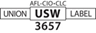
Forms must be received by Monday, June 2, 2025.

